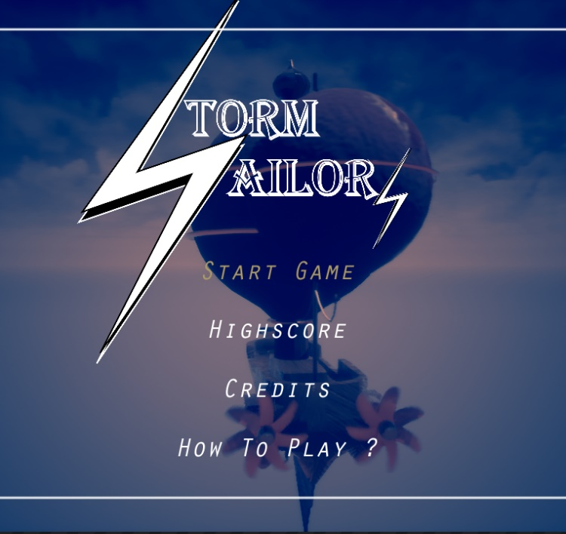

|  |  |
| --- | --- |
| A picture of a winding road and trees  Storm sAILORS  GDD | Abstract  This is a GDD document for our arcade project. It will describe the process behind the building and the design of the game itself.  Mariano Cayzac, Jay Hriscu, Gary De Melo  GOPRO1 - Group Project |

Table of Contents

Updates on the Document 3

Update: 03/29/2020 3

Update: 04/15/2020 3

Update: 05/12/2020 3

UPDATE: 05/24/2020 3

UPDATE: 06/23/2020 3

The Game overview 3

Design Goals 3

Target Market 4

Art dIRECTION 4

Theme/World/Style 4

***Player/s*** 5

***Enemies*** 6

Bomber ships: 6

Cruiser Ship: 7

Heavy Cruiser: 8

Bosses 8

Animations 9

Audio 9

Game Design 9

Mechanics 9

time 9

Power-ups 10

Super charge 10

Lightning Dash: evasive maneuvers 10

Enemies 11

**Standard** 11

Bosses 11

The Cyclone: 11

Thunder Beast: 11

The Lighting Queen: 12

The Destroyer: 12

Scoring 12

Rewards 13

Score points per enemy type: 13

Game Loop 13

Technical Design 14

Interface/Controls 14

Interface 14

Controller 15

Arcade Machine 15

Feedback 16

Level Design 17

Thematic Elements 17

Narrative Elements 17

Structure 17

Game Flow 18

# Updates on the Document

### Update: 03/29/2020

Change in game Overview (from coop to solo), due to restricted time to work on. Change on the designer goals to make it more adequate to groups ideas and project’s goals and thoughts.

### Update: 04/15/2020

Target Market change, more fitting and describing of the game’s intended audience. Update in art direction, player and enemy information added. New power-ups added, as well as a rework on the players ultimate and dashing ability. There is been also a change on the controller scheme and description as well as in the items and collectibles.

### Update: 05/12/2020

Power-up obtaining revisited: Now every enemy can drop them but will have a different color on them. Power ups will remain in place for a certain amount of time and then disappear (5s). Change on scoring system: Now there another system inside it that will calculate the amount of points the player has to them decide to spawn a boss or not.

### UPDATE: 05/24/2020

Technical Design update: new blueprints and design for the Arcade Machine. Addition of pictures at the art direction and the mention of the introduction of animations into the game. Audio added to the game.

### UPDATE: 06/23/2020

Technical Design update: updated user interface. Addition of pictures at the art direction, as well as the artist description itself. Music was added to the game as well.

# The Game overview

Storm Sailors is a single player side-scroller shooter. With environment change, three different type of normal enemies, unique abilities and up to 4 bosses, this gameaims to make it both challenging and dynamic for a player.

## Design Goals

When we think about the theme “Lighting and Thunder”, we think of power. An unstoppable force of nature. But you can’t have power without having some sort of control over the events happening, and you cannot have control without decision. You cannot make decision without information. The biggest challenge of making this game will be to make the player feel immerse and powerful while still being challenged by every wave of enemies they are facing.

Another big challenge ahead is making this game unique, since there has been a wide variety of platformers and side scrollers on the market. We come up with a few unique ideas. The first thing we will try to incorporate are abilities and power ups that have some connection with the world and theme, and balance them so it doesn’t go ridiculously out of hand. This ability and powerups will be discussed fully later this document.

We want each boss to have a unique feature that will force players to take different approaches. There will also be a combo multiplier that will increase the amount of points gathered by the player and therefore the game will become harder. This is only a fact of how the player involvement in the game will affect the overall experience. We plan to expand on this idea during the whole building process.

## Target Market

Storm Sailorsis made for everyone to enjoy. From people that only want to have fun and not take many risks to those who gasp at getting the lead on the score boards. Set with an intuitive design and simple controls it aims to target all audiences.

# Art dIRECTION

## Theme/World/Style

The stablished theme is “Lightning and Thunder”. We decided to base our world to this theme, but with a few interesting changes in the style and design. The world is set in a futuristic sci-fi version of earth, where there are pirates that navigate “Space Corsairs” to fight against each other. These ships gather power from lightnings to charge their weapons and defeat their rivals. All these will be displayed with a 3d stylized steampunk.

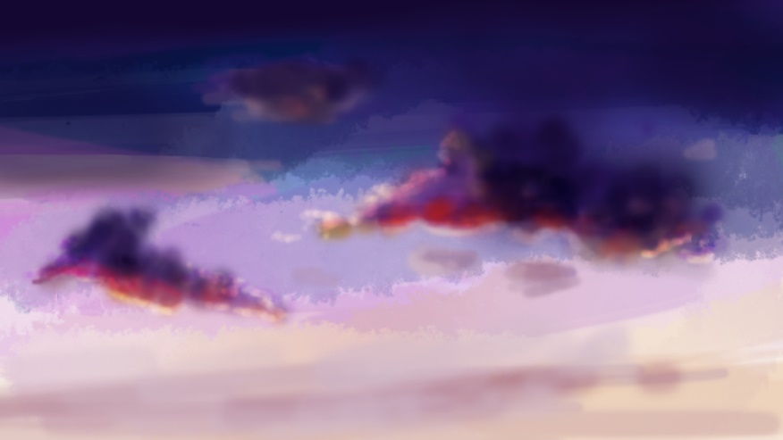

*The whole world will also be presented in a dark fantasy style, with darker lightning effects which will help in setting up a chaotic, yet eye-catching atmosphere.*

## ***Player/s***

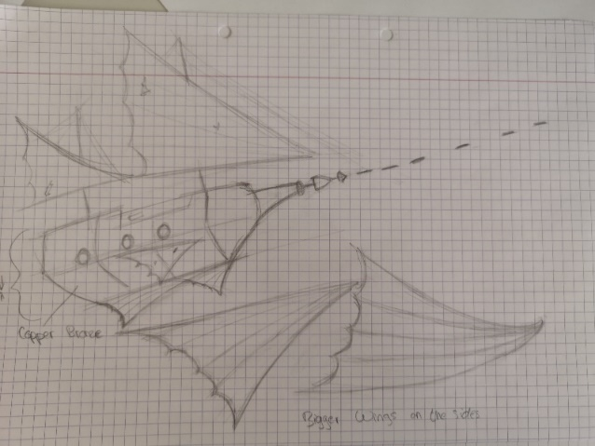The Tempesta, is a standard cruiser with a tesla tower on the front that has the capacity of absorbing lightnings. This can later be use for charging its special lightning cannon, allow it to have fast evasive maneuvers and shoot standard cannon balls units through well-equipped, highly advanced cannons.

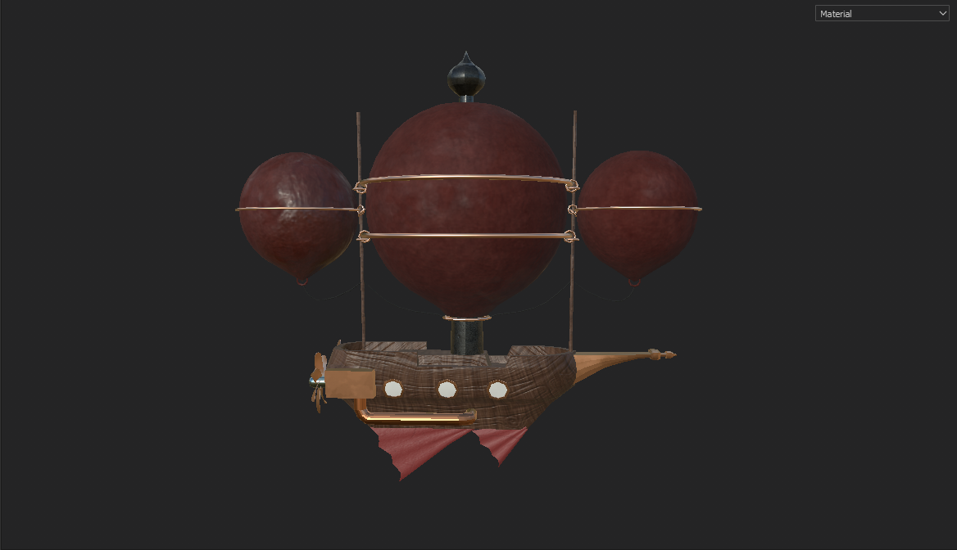The metal box on the rear sides are used to power up the propellers at the back of it, which comes through the pipes from the engine inside the ship which you can not see. The three big balloons are tied together using big metal rings around them, ropes and two large wood sticks, aligned in a vertical row in the X axis with metal rings that keep them together in the middle of each stick. The flags underneath is meant for stabilization and control over maneuvers for left and right. Finally, a big metal in the front the shoot the lightning canons.

## ***Enemies***

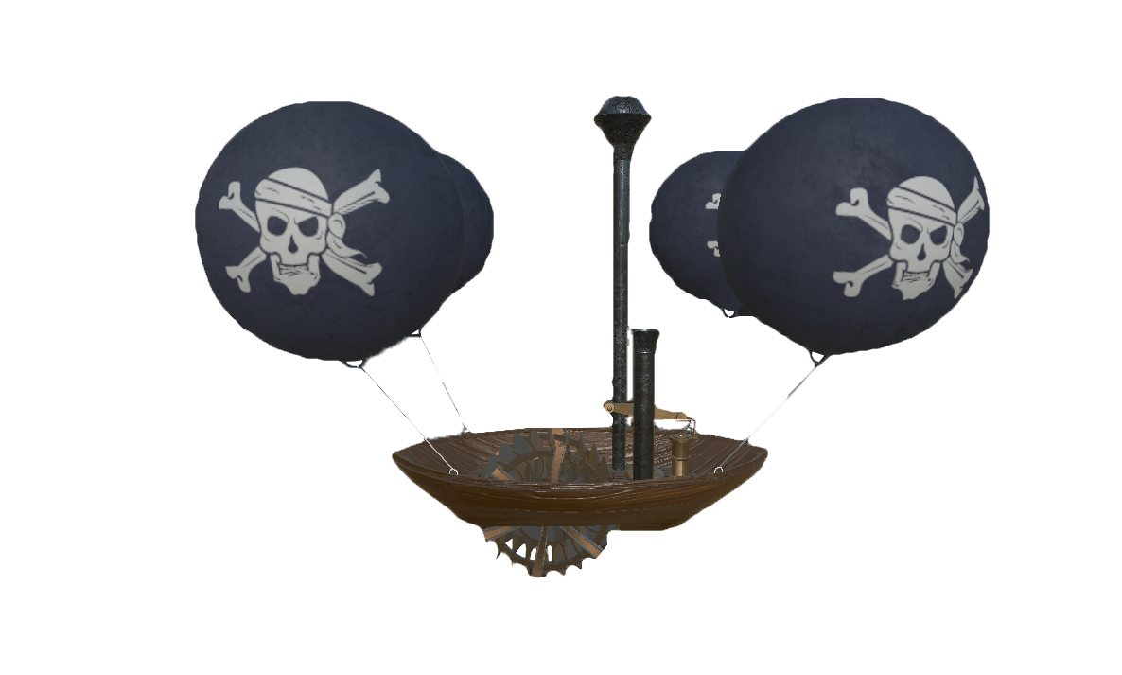

Bomber ships:

These ships were not meant for war but their light and simplistic design, as well as a low cost of production, makes them a perfect candidate to be used as kamikaze ship. Due to the reduce weight due to no armor, it allows them to strike fast and become extremely dangerous in highly populated areas, dealing great amount of damage.

Here the four big balloons carry the weight of the whole ship and the steam engine is used to keep the windmill rotating, thus giving it the force to move forward.

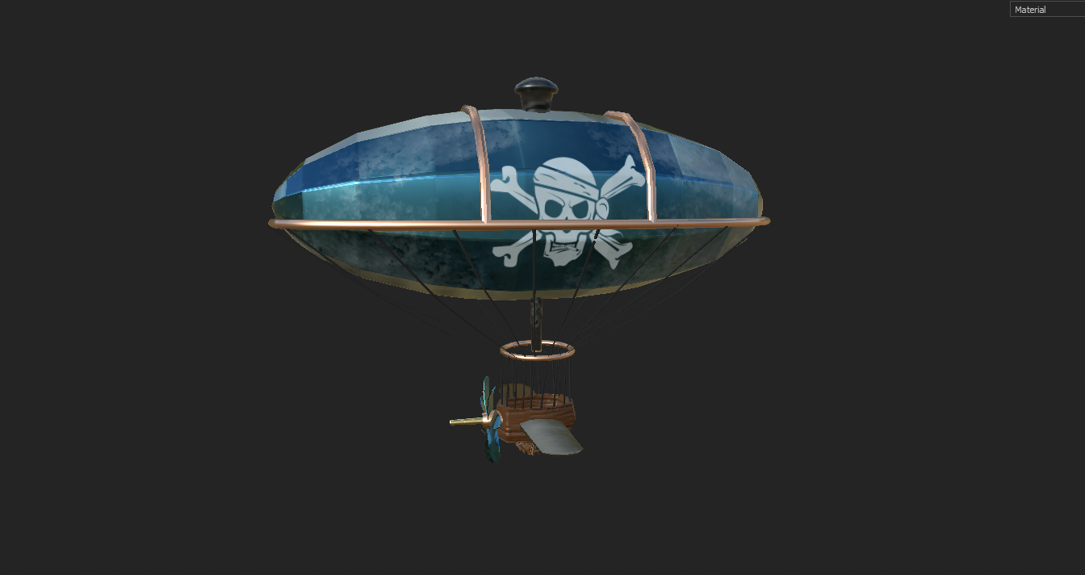

Cruiser Ship:

This ship might not look menacing, but it loaded with top tech lightning cannons and ready for battle.

The design of the balloon is meant to resemble a zeppelin air ship, because of its streamlined balloon shape, it gives it more dynamic and speed while gliding through the air. The metallic blue texture on it makes it less vulnerable, with a noise texture to give it a frozen look, that indicates it being high up in the air for a long time.

The propeller on the front takes the air and sends them underneath the wood vessel to the windmill which gives it the extra boost to attack when you least expect it. The wings on the side keep it stable and gives it the ability to maneuver left and right. Lastly the gun in the front for shooting, makes it a dangerous enemy which you will want to watch out for.

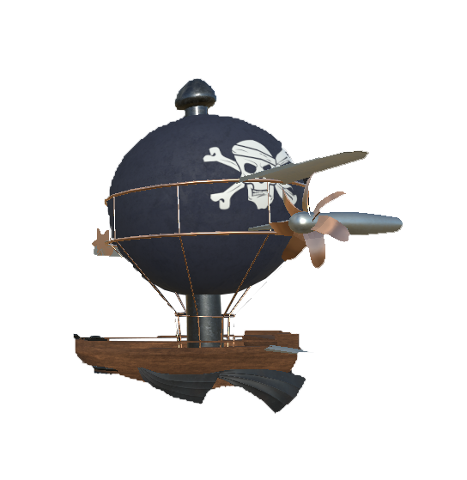

### Heavy Cruiser:

A similar design was chosen for the heavy cruiser although, equipped with extra armour,

## Bosses

## Animations

An animation for the explosion of the ships where added to the game to give the player the feeling of power and gratification for killing an enemy. The animation was done in aftereffects and then added as a sprite sheet to unreal to then be converted into an animation. A second animation had to be done since the first one was not in frame and players where able to see an unpleasant cut on the animation.

Small Animations on all the ships to give them the extra touch, and more importantly a sense of weight as well as it makes them more believable.

## Audio

Sound effects were added to help with the immersion and work as input for the players action. Allowing them to feel like their actions have meaning and affect the world around them. This sound effect varies from explosions to the use of lightning and lunching mechanisms.

A total of 5 songs were made for this game, from which 3 were introduced. One being the main menu song, which is meant to be catchy and energizing to let the player know that the game is fun and challenging, but not too dense to make them worry or feel threaten/overwhelmed. The second song was meant to be a bit quicker, and get in rhythm with the actual gameplay, allowing the player to easily enter a state of game flow. The last song is meant to be even more intense, signifying that a big fight is approaching, allowing the player to understand there is a boss fight and setting the scenario/mood for it.

All these songs where done by using the application Bosca Ceoil, to connect the audio with the dark fantasy elements we choose minor and harmonic minor scales. After a long time of testing, we decided that the most fitting instruments were the use of simple drums, harmonica, and an accordion. For a small fraction of the boss song you are also able to hear an electric piano to increase the tension and the dramatic weight.

# Game Design

## Mechanics

### time

Time is an important mechanic on this game, since it won’t only serve as a guidance to the player to know how much time he has spent on the game, since spending time without killing enemies will reset the score multiplier. Surviving for long amount of time will also be rewarded at the end of the game, where the player be awarded with 200 point per minute spent in the game.

#### Multiplier

The multiplier has a very important role on this game. The higher it gets, the faster the game goes. Making enemies more dangerous and the difficulty to grow exponentially. It is within the player to decide how much is he willing to sacrifice for a higher score multiplier.

### Power-ups

Power-Ups on this game can be collected during the gameplay, they can be dropped by destroying any enemy which is highlighted in golden color, each of them will have a symbol to ease players recognition. Once dropped the items will remain in game for 5 seconds. If the player grabs them or the 5 seconds have passed the item will be removed from the map to avoid overpopulating it. Players can use the Power-Up at any section of the game since they can be stocked up to a maximum of 2. The stored power-ups will be consumed in the inverted order of its obtention. This means, that the last power up stocked will be the first to be used when the power-up button is pressed. There are eight types:

* Shields: When consumed, it will display a shield in front of the player for 3 seconds. This shield will block any upcoming damage until it disappears.
* Health-Up: When collected it will add one more life to the player that grabbed it.
* Double-Tap: It doubles the number of projectiles thrown by the player, lasts 10 seconds.
* Bullet Overcharge: Throws tiny bullets that do half the damage of the normal ones but can shoot them a lot faster. Basically, like a minigun. It lasts 10 seconds.
* Thunder Touch: thunder waves will be emitted around the player, within a certain radius. These waves will push enemies and objects away.
* Lightning mine: live lighting mines that will be thrown forward that will explode when an enemy gets near them.
* Taser charge: throw two tiny balls of electricity that are connected by a small ray. Enemies that go in between the balls will be hurt by the ray.

### Super charge

This mechanic is introduced with a bar that will charge with enemies killed over time. Once the player reaches the bar’s maximum, they will be allowed to use their super charge ability. This ability is an ultimate that can be activated by pressing both shooting and ability buttons. However, next to this mechanic we have the lightning dash that will take some power from this bar each time it is used. The full explanation of such ability will be detailed bellow.

### Lightning Dash: evasive maneuvers

This ability can be used by pressing the third button on our controller layout. It would allow the player to quickly dash into any direction, also avoiding any possible incoming damage coming from it. This means that if a player dashes towards a bullet, they will go through it without receiving any damage. As previously mention, this ability will take some of the ultimate’s bar power to be used.

## Enemies

### **Standard**

There are three types of standard enemies on the game. You are introduced with the weakest of them all, called the “bomber ships”, these ships will not shoot at the player but will target them and explode on collision, taking one life. Bomber ships have the lowest of health, needing only one shot to be destroyed. Further into the game you will encounter the “cruisers” which will shoot at the player, these light armor ships will not approach the player, but will shoot at them and move around instead. These enemies will need to be hit twice before they get destroyed. Finally, you have the “heavy cruisers”, which are heavy armored and will take 4 shots to take down. This enemies have a similar type of moving but they are a bit slower.

## Bosses

Bosses enemies, also known as “frigates”, will have unique features that will present different kind of challenges to the player. This type of enemy would be significantly bigger than the standard enemies and will take a considerable amount of shots to be taken down. There are four of them:

### The Cyclone:

**Unique Power:** Will create powerful winds that push the player to the further left of the screen. Only allowing them to go upwards and downwards.

**Shooting Mechanic:** This enemy will also shoot a big laser that the players will have to dodge. This laser will initiate by showing the player where it will hit. While firing it will slowly move either upwards or downwards for a bit forcing the player to dodge it unless they want to lose one life.

**Movement:** The Cyclone will only move upwards and downwards.

### Thunder Beast:

**Unique Power:** Extra health, this is the most resistance frigate of all.

**Shooting Mechanic:** This ship will throw sound waves at the player which they will have to dodge to avoid losing life. This sound waves will be sliding to the left and will block the path except for some holes that will allow the player to go through to avoid getting hit.

**Movement:** This ship will stay still on their position.

### The Lighting Queen:

**Unique Power:** full movability, allowed to move to any point of the screen.

**Shooting Mechanic:** This one will throw lighting balls that will move to a random position and explode, blasting lighting rays withing a certain radio, forcing the player to move around constantly.

**Movement:** 8 dimensions.

### The Destroyer:

**Unique Power:** This frigate will have the ability of charging to the player. If a player collides with it, they will lose one health point.

**Shooting Mechanic:** This boss will shoot multiple times in random patterns. Also forcing the players to move constantly around the screen.

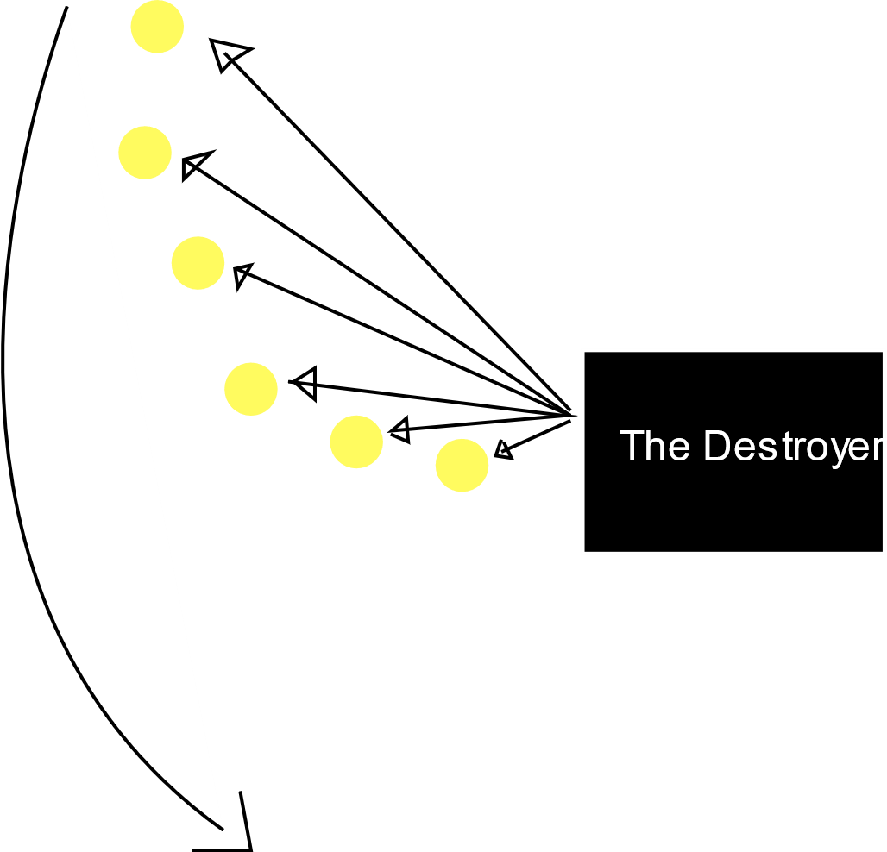Types of patterns:

* Counterclockwise blasting: it will shoot many bullets in clockwise direction like the following illustration.

**AND**

* Clockwise blasting: same as the counterclockwise but to the opposite direction.
* Energy bombs: just like the Lightning Queen, this ship will shoot balls of energy that will explode causing the player to lose a health point if they are withing reach of the explosion radius.
* Lightning strikes: Can cause lightning strikes that will come vertically down or up from outside the screen. At random positions.

**Movement:** Without counting the charge (which will be a horizontal movement in which first it goes all the way to the left with a considerable speed but then slowing going back to the right side of the screen), this ship will move upwards and downwards only.

## Scoring

The score system will be tied to the number of enemies you killed. There will be a score multiplier that will increase depending on the number of enemies you killed. This multiplier will be reset when the player spends 3 seconds without killing any enemy. Inside this system they will be another controlling when to spawn a boss. A boss will spawn every 10,000 points. When, and only when, the boss is killed, the system will then start counting again to see when the next boss will spawn.

## Rewards

Players will be rewarded with one random power up and one life each time a boss is defeated. The multiplier system in the score also will work as a gratification for the player’s skill. The higher their multiplier, the harder the game gets and the faster the score increases.

### Score points per enemy type:

-Standard enemies:

Bomber: +50

Cruiser: +150

Heavy Cruiser: +300

-Bosses:

The Destroyer: +2000

Other Bosses: +1000

## Game Loop

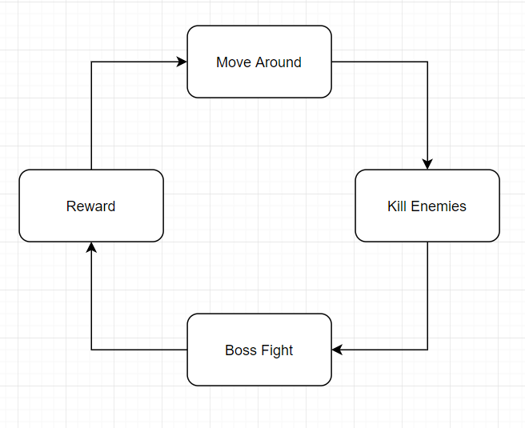

# Technical Design

## Interface/Controls

### Interface

The interface will have the amount of health displayed on the left upper corner, while the score will be set on the right upper corner. The time will be set in the middle, while the multiplier will be right next to as long as its higher than x1. All what I have mentioned should look like this:

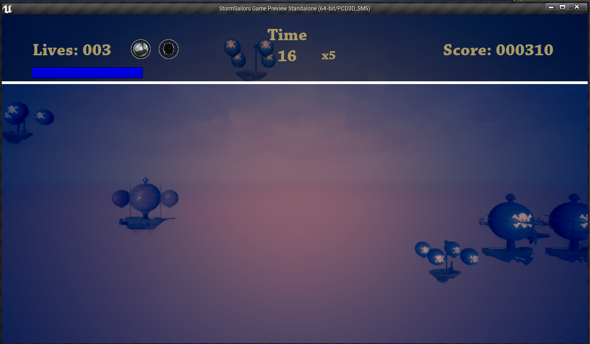The previous imagine is just a quick mock-up to show how the interface elements will be displayed. One thing I should mention is that whenever the multiplier appears next to the timer, the score will change color to match the multiplier. With this we hope that the player will understand their relationship.

## A picture containing game Description automatically generatedController

As you can see in the picture above, the player can move in any direction with the stick. There is a shoot button and a power up button, as well as the dashing. If you press both, power-up and shoot, at the same time you get to use your ultimate attack which is a more powerful attack.

## Arcade Machine

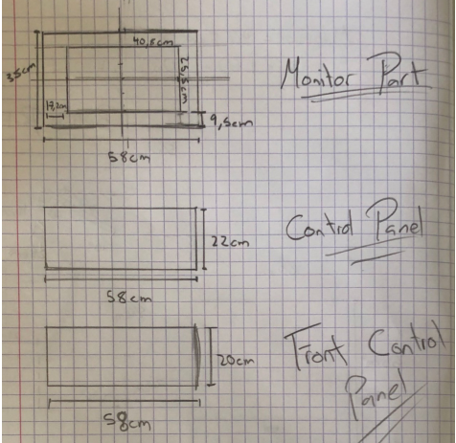

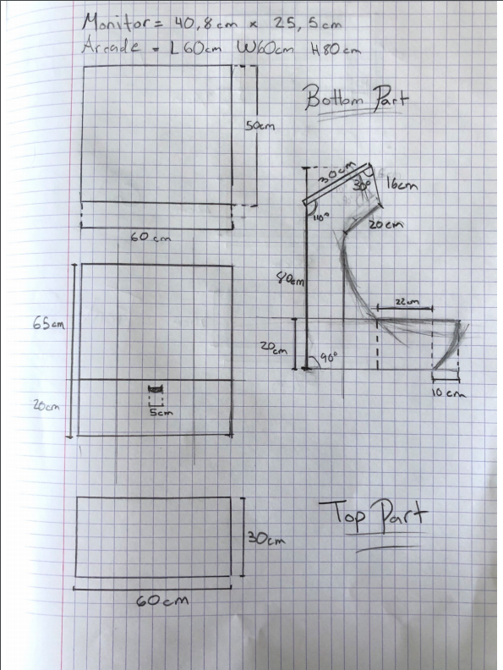

*We went for an immersive design. As you can see from the sides, it has a ship shape with the logo of the game in the front. The arms of the arcade are 10 cm longer than the control center (machine’s joystick and buttons), to give a feeling of being inside a ship*

## Feedback

Storm Sailors offers the user a small amount of feedback. This will be listed down below:

* Character flashes when hit to tell the player they have suffered damage.
* Bosses flash or play a specific animation whenever they are preparing to throw a powerful attack.
* Score changes color with the multiplier to show the player that the multiplier is having an effect in the score.
* Ships blow up to show they have been destroyed.
* Bosses design changes with their health to show the player the amount of damage they are dealing and how much more time they need to destroy it.
* While collecting a power-up, there will be a sound and a small particle effect.
* When Players collect an ultimate power up a lighting will strike their ship and they will be highlighted with a yellow aura.

# Level Design

## Thematic Elements

Alongside with determinate theme, we decided to also make this game a pirate theme game with a 3d steampunk art style, were the game jumps right into action. We choose a dark fantasy genre for this game because it is perfect for incorporating a dark and gloomy atmosphere. We use this to create a merciless, suspenseful mood, which will be emphasized by the intense gameplay. This game takes an exhilarated tone to expand and make emphasis on what is happening on the gameplay.

## Narrative Elements

## Structure

#### Items and collectibles

You will have eight different power-ups that will spawn randomly on the game, this power-up will give advantages to the player, which will allow them to get out of complicated scenarios or survive a little bit longer.

#### Obstacles/Enemies

As previously mentioned on this document, there are three different types of “standard” enemies and 4 bosses. For the standard enemies you have the **bomber ships** which would target the player and blow up, dealing one life point of damage, the **cruiser** which is a light armored ship that will shoot at the player as well as moving around the screen to avoid getting hit, and the **heavy cruisers** which will move a bit slower than the normal cruisers and will have double the amount of health.

The biggest obstacle on this game, however, are the bosses. Each one with a unique feature, which will challenge the player’s skill and force them to adopt different strategies.

#### Critical Path

Head forward while killing enemies to increase your multiplier and get the highest score possible. Avoiding enemies may be another path for those you don’t want to deal with intense levels of stress.

#### Path finding

Enemies will have an integrated pathfinding mechanic that will allow them to track the player at any time. For enemies such as the bomber, this is crucial since they need a responsive pathfinding mechanic to be able to go towards the player and damage them.

#### Triggers & Events

There will be score triggers that will generate boss fight events. These events will be triggered every time the player’s reached 10,000 points. During these events, the game will spawn a boss, the next trigger counter will start once the boss is defeated. Bosses will be chosen randomly with a system that will prevent the same boss to appear twice or more times in a row.

## Game Flow

#### Objective/Guidance

The primary objective is to this is to destroy as many ships as possible to get the highest score. Time also adds up to the score system at the end, so you must make sure to last for as long as you can. The only guidance the player will have would be the system’s feedback and the instruction menu before starting the game.